Date:23/01/2026
12.Demonstrate virtualization by Installing Type-2 Hypervisor in your device, create and configure VM image with a Host Operating system (Either Windows/Linux), using VMware workstation.

AIM: To demonstrate virtualization by installing a Type-2 hypervisor (VMware Workstation) and creating a virtual machine with a Windows or Linux operating system.

SOFTWARE USED
- VMware Workstation
- Host Operating System (Windows / Linux)
- Guest Operating System ISO (Windows / Ubuntu Linux)
PROCEDURE:
PROCEDURE:
- Download and install VMware Workstation on the host system.
- Launch VMware Workstation and select Create a New Virtual Machine.
- Choose the Guest Operating System ISO file (Windows or Linux).
- Configure virtual machine settings such as CPU, RAM, and storage.
- Create the virtual disk and finalize the VM setup.
- Power on the virtual machine and complete the OS installation.
- Verify that the guest operating system runs successfully inside VMware Workstation.

Output:
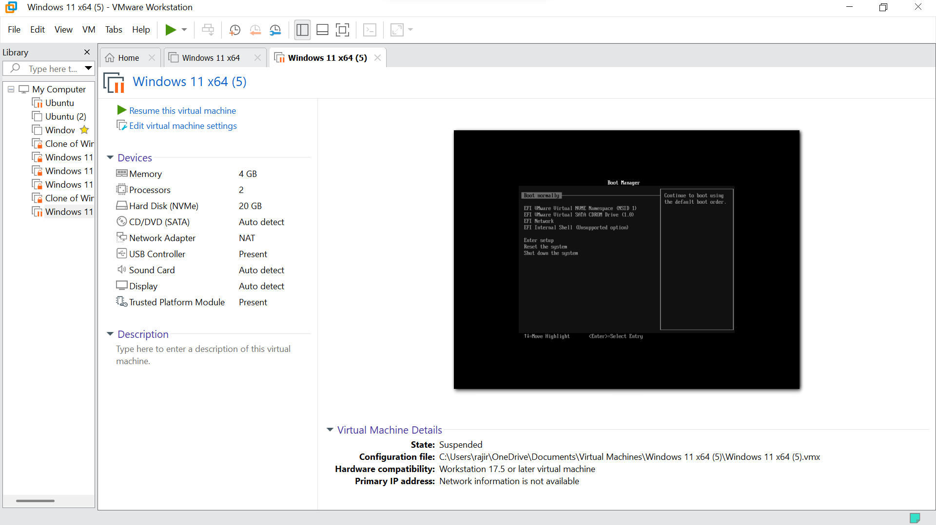

RESULT:
Thus, virtualization was successfully demonstrated by installing VMware Workstation and creating, configuring, and running a virtual machine with a Windows/Linux operating system.

